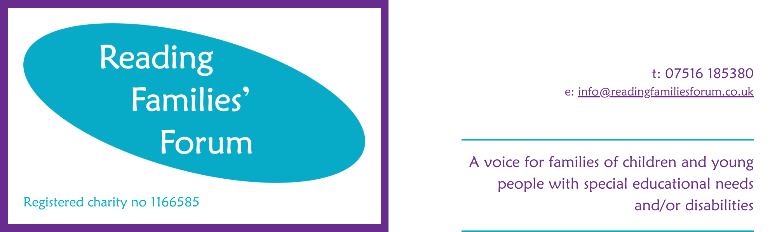

Application Form

THE INFORMATION YOU SUPPLY ON THIS FORM WILL BE TREATED IN CONFIDENCE.

Section 1 Position Details

Job Title:
Closing Date

Section 2 Personal details

Title: |  | Last Name:
First Names:

Address:

Postcode:
Home Telephone Number:
Mobile Telephone Number:

E-mail address:

Are you eligible to work in the UK? | Yes |  |  | No

Do you hold a full UK driving licence? | Yes |  |  | No
If yes, Do you have any points or convictions etc? :

Section 3 Rehabilitation of Offenders Act

Have you ever been convicted of a criminal offence? | Yes |  | No
Have you any prosecutions pending? | Yes |  | No

If yes, please give details / dates of offence(s) and sentence:

Section 4 Education

Date From | Date To | Name of School | Examinations taken and Qualifications Gained (Specify Grades)

Section 5 Employment Record

Please list chronologically, starting with current or last employer
Name and Address of Employer | Date From: | Date To: | Job Title/Job Function/ Responsibilities: | Reason for Leaving

Section 6 Suitability for the Post applied for
To help us short-list for this position please provide details of how you meet the criteria outlined in the Person Specification. This can be found at the end of the Job Description for this role.

Please refer to your career history, skills and experience in support.

Section 7 References

Please give the names and addresses of your two most recent employers (if applicable). If you are unable to do this, please clearly outline who your referees are. (NB. References will only be taken up after interview.)

Reference 1 |  | Reference 2

Name: |  | Name:

Their Position (job title): |  | Their Position (job title):

Work Relationship: |  | Work Relationship:

Organisation: |  |  | Organisation:
Dates Employed: |  |  | Dates Employed:

Address: |  | Address:
Postcode |  | Postcode

Telephone Nº: |  | Telephone Nº:

E-mail: |  | E-mail:

Section 8 Declaration
I confirm that the information provided in this application is both truthful and accurate
 | Signed: |  | Date:
Reading Families’ Forum undertakes that it will treat any personal information that you provide to us, or that we obtain from you, in accordance with the requirements of the Data Protection legislation.

Please return this form to fran@readingfamiliesforum.co.uk

